**Sequence Diagram:**

A sequence diagram is a part of UML (Unified Modeling Language). It is a type of interaction diagram as it describes how the group of objects work together. It is used by software engineers, business professionals to analyze the interaction between different objects and actors when performing some event. The sequence diagram has a lot of symbols like actors, lifeline, activity, alternative, objects, loop, messages.

GharDailo Sequence Diagram:

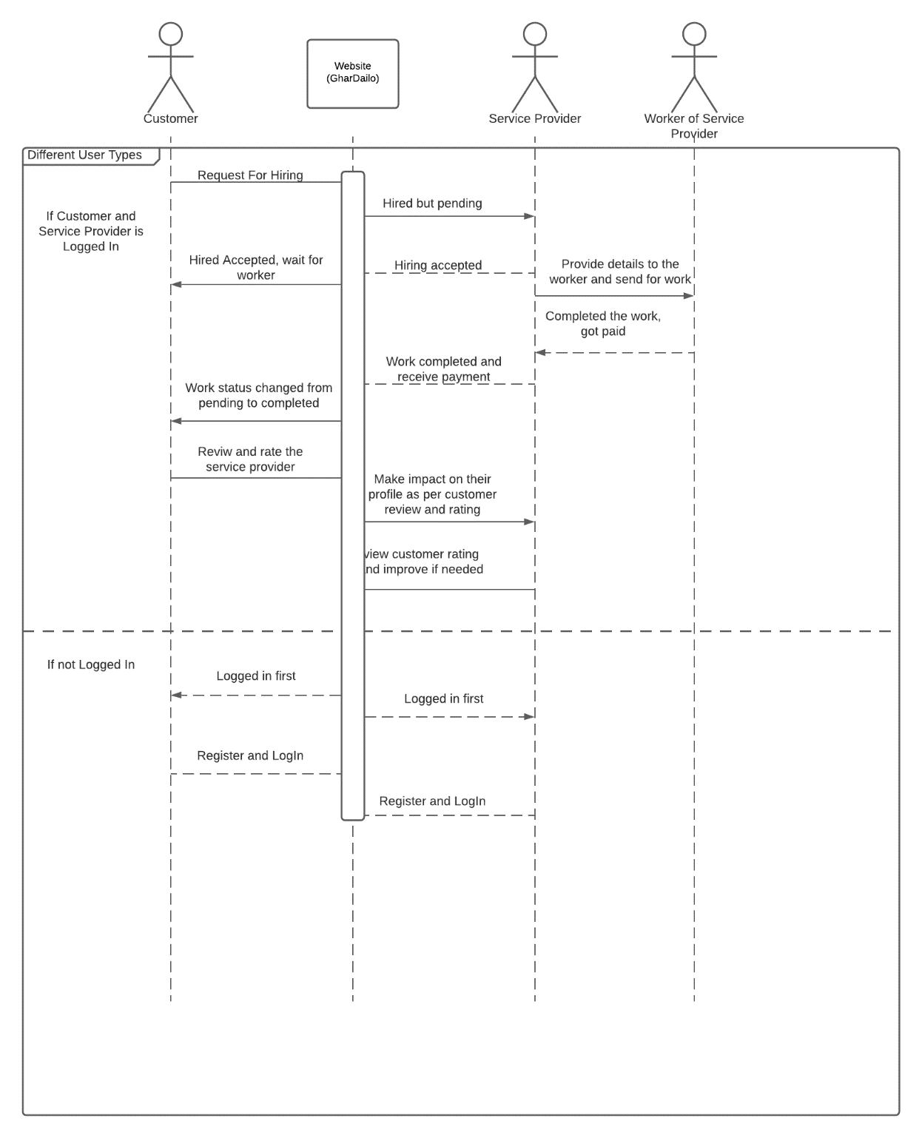

The above images show the sequence diagram of GharDailo. There are different actors like a customer, service provider, and worker of service providers. There is one object website itself. The diagram also shows how a website works for different user types i.e. either login or not. If a customer is logged in we can see that he can access all the features of the website like hiring, rating, reviewing but for the new customer they must create an account and logged in to access these features. In the diagram, websites redirect them to a login page with a login first message. We can see the vertical box line below the object (website) shows the interactive activation of particular objects in whole activity or event. We only apply activation to the objects not to the actors.

**PROTOTYPES**

High fidelity prototype helps understand how the product looks and works. It gives clarity to the team about how websites look and work, it is flexible too as we can change the design and workflow of a website if required. We have use Figma software to create high fidelity prototype and the above shows the prototype of the most important pages of our websites.

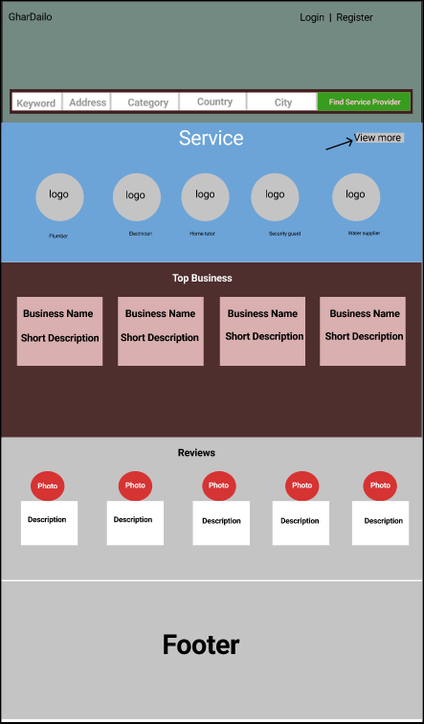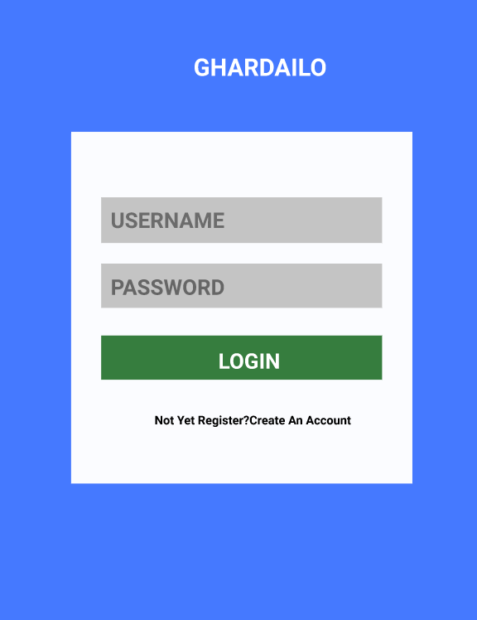

Figure : GHARDAILO Login Page

Figure : GHARDAILO Home Page

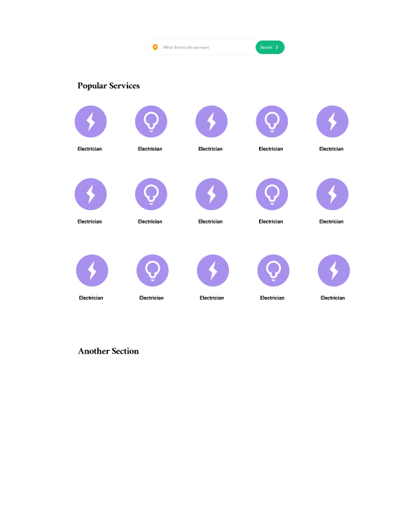

Figure : Service Page

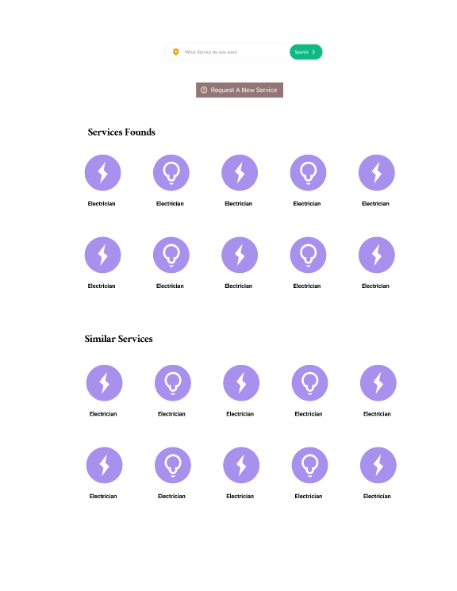

Figure : Results after Searching Services

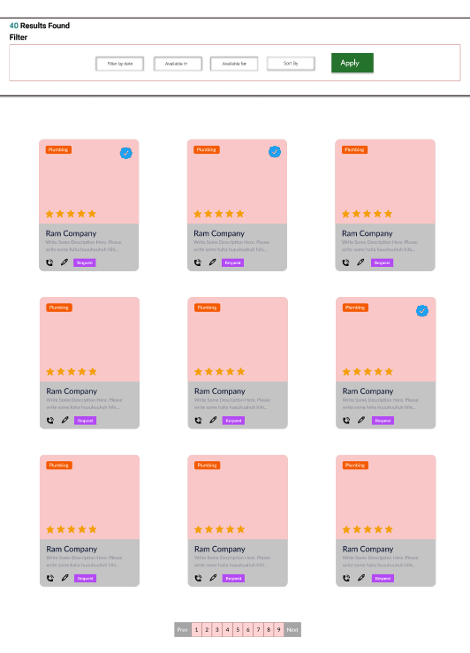

Figure : Result after searching Business

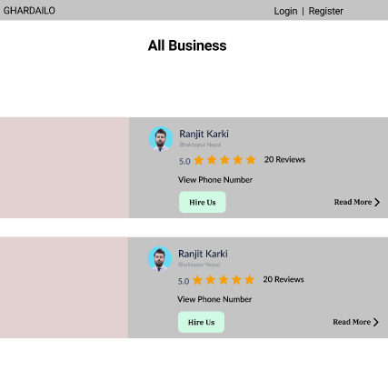

Figure : All Business Listing Page

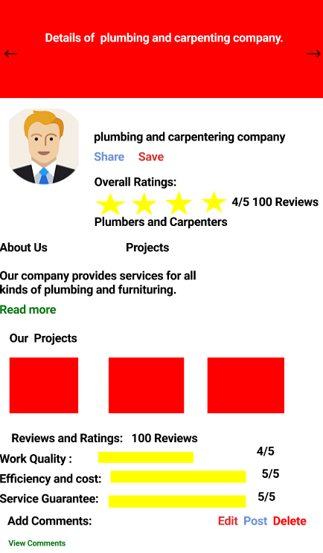

Figure : Business Profile Page

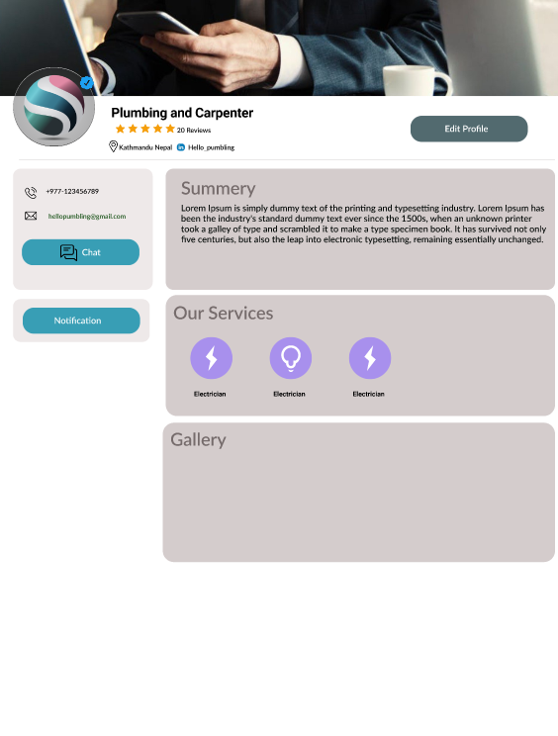

Figure : Business Page Frontend for Customer or user

**Project Proposal**

**Tutor Number**:

**Tutor Name**:

**Group Name**: GRASS

**Group Leader**: Anup Raj Rijal

**Group Members**: Anup Raj Rijal, Ranjit Karki, Shankar Tamang, Gauri Shankar Sharma, Samir Thapaliya

|  |  |  |  |  |  |
| --- | --- | --- | --- | --- | --- |
| ID | 190111 | 190130 | 190154 | 190199 | 190103 |
| Full Name | Anup  Raj Rijal | Ranjit Karki | Shankar Tamang | Gauri Shankar Sharma | Samir Thapaliya |
| Mobile | 9860809725 | 9840276656 | 9818026989 | 9816346714 | 9843807070 |
| Email | 190111  @softwarica.edu.np | 190130  @softwarica.edu.np | 190111  @softwarica.edu.np | 190199@softwarica.edu.np | 190103@softwarica.edu.np |

Project Title: Our project title is ''GharDailo" which is designed to provide optimum services and solutions to the customers according to their problems. Customers can use our product to get the services like plumbing, carpentering, and many more.

Problem trying to addressed:

Nowadays everything is going digital so we are also making the product that helps the customers to get proper services for their related problems online. Nowadays everyone is busy so if a person needs a plumber where does he/she search for them? how they will search for them? And the situation will become even difficult if a person is new in the locality.

Also once the work is done there is no work guarantee, who is responsible if the work is incomplete. So our mission is to let the user get all these facilities in one place i.e. GharDailo

The Proposed Solution:

* Users can easily choose any required worker from their comfort (Home).
* Users can trust the worker and have a work guarantee through the persons/company partnered with us.
* Users can get flexible services according to their requirements and choices.
* Users can complain, review the worker according to their work output.

Possible competitors:

* HarGharSewa
* GharSewa
* Sajilo Marmat Sewa

Issues:

* To finalize the workflow of the website or how the business model works.
* Only virtual meeting was possible

Updated Project Plan:

While working on a team we have to assign and manage different tasks to each team member so it will be difficult to manage these tasks without any team management software. There are different team management software but among them, we choose Asana as it is widely popular, has a good interface, is easy to use and it has a free version too.



Figure: Our Group profile in Asana

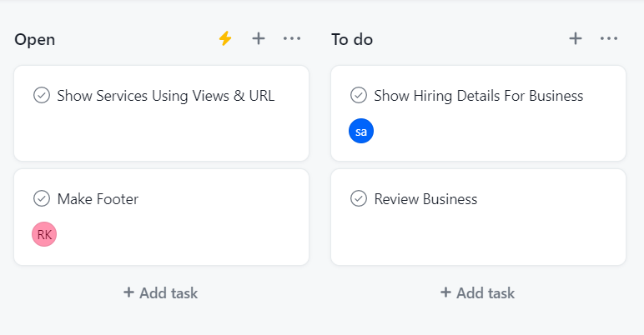

Figure: Tasks assigned to the user

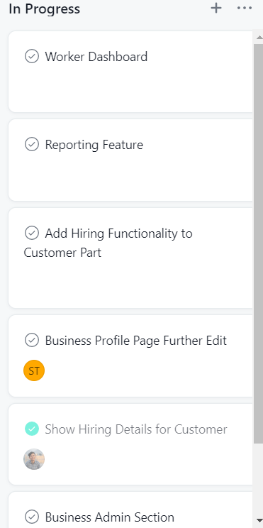

Figure: Taska that were in progress

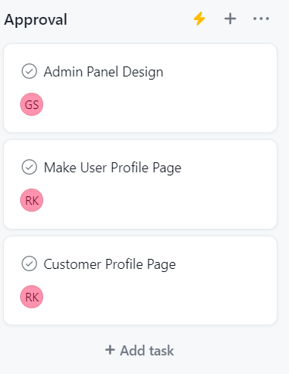 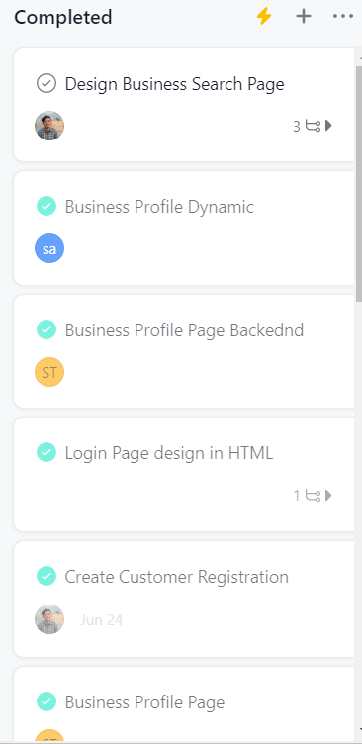

Figure: Tasks that are approved Figure: Completed Tasks

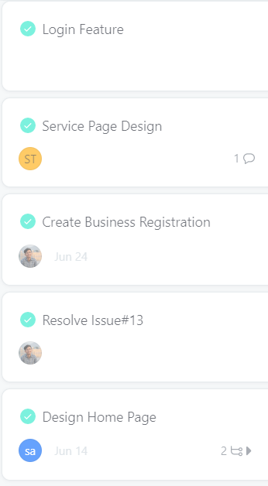 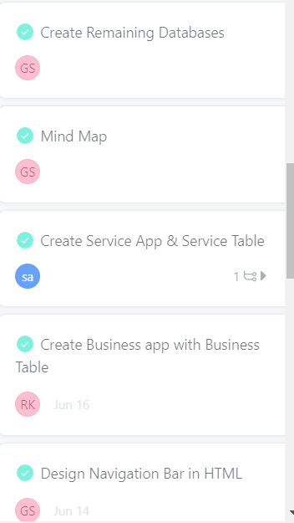

Figure: Completed Tasks Figure: Completed Tasks

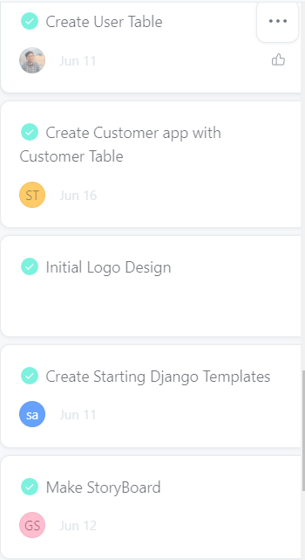 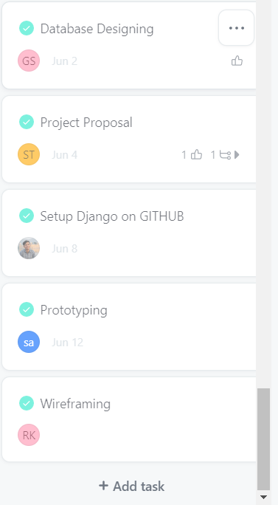

Figure: Completed Tasks Figure: Completed Tasks

Source Code:

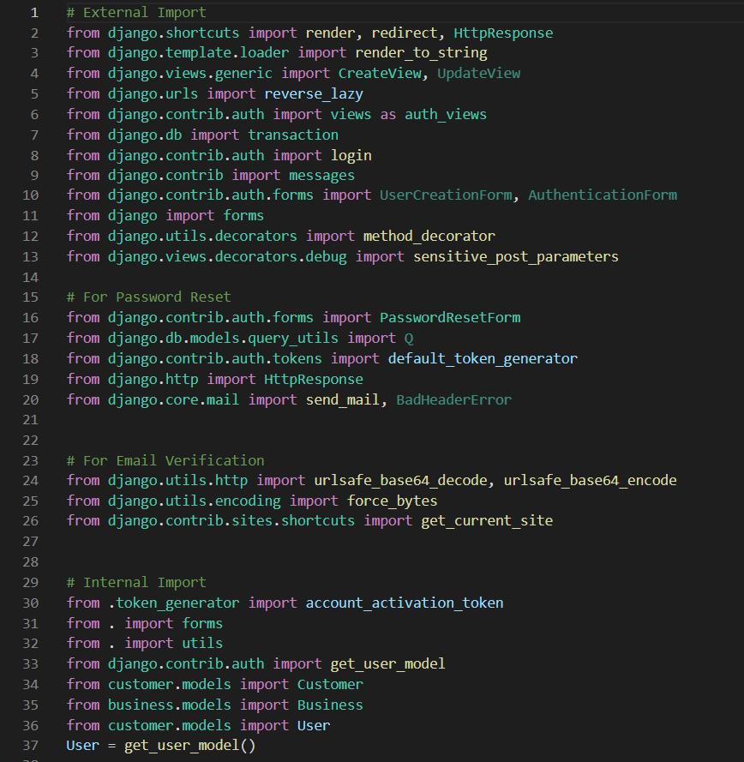

Figure: Different imports needed for the projects.

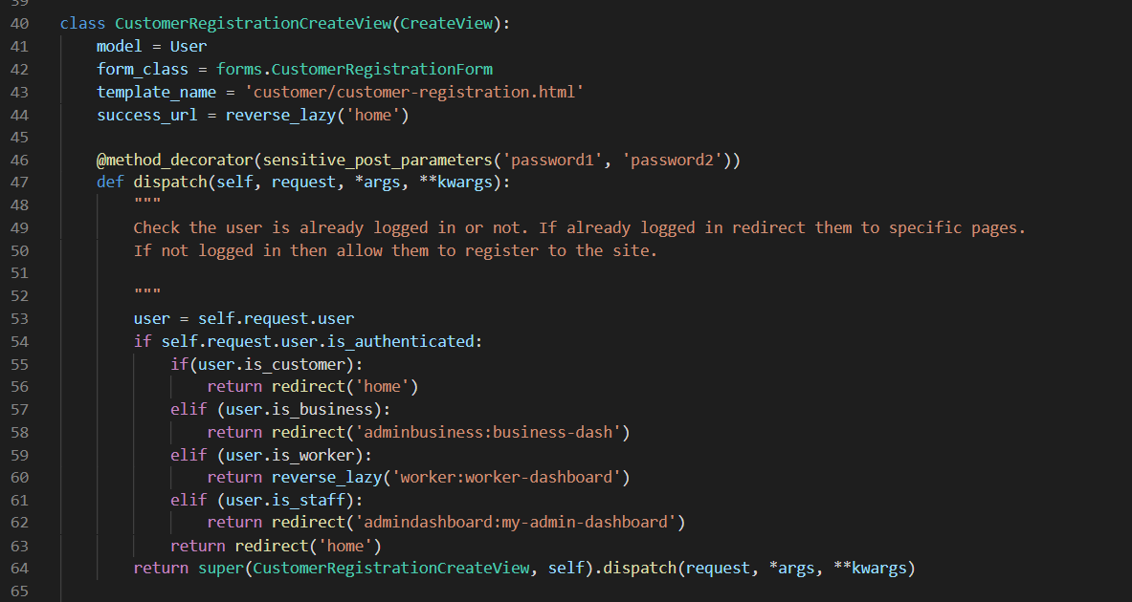

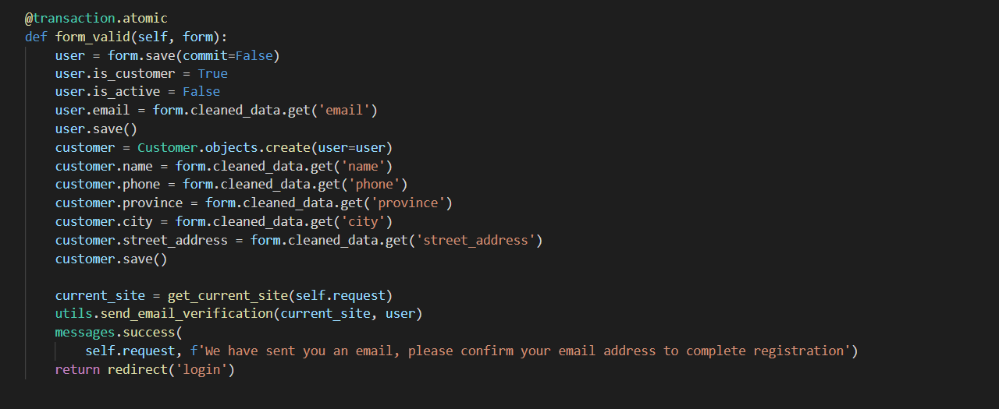

Figure: User registration and email verification

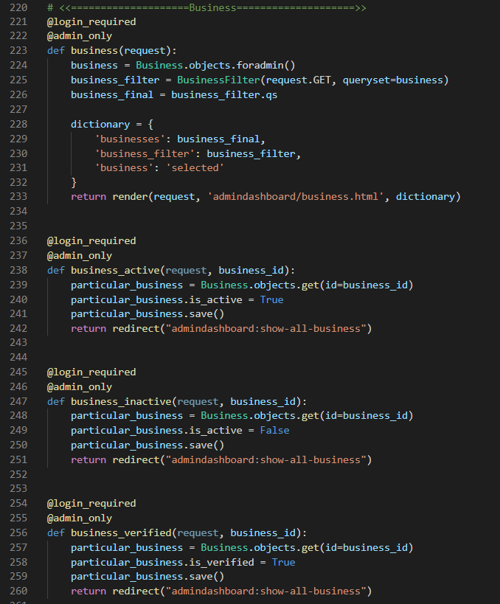

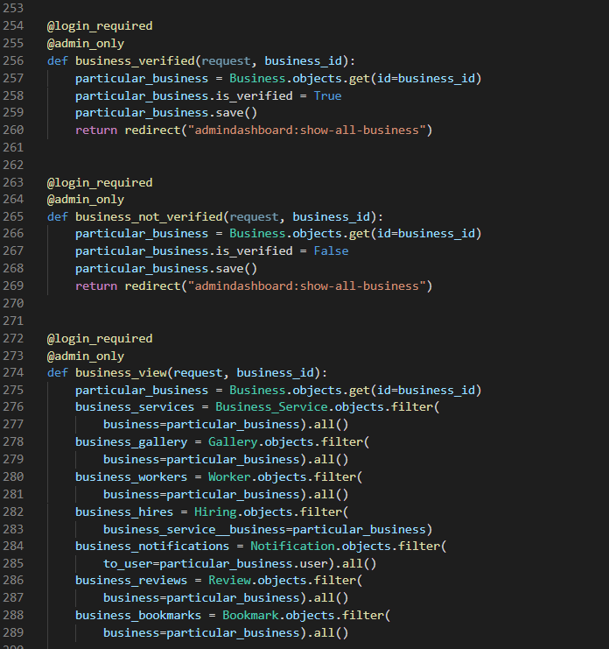

Figure: All business things handled by admin

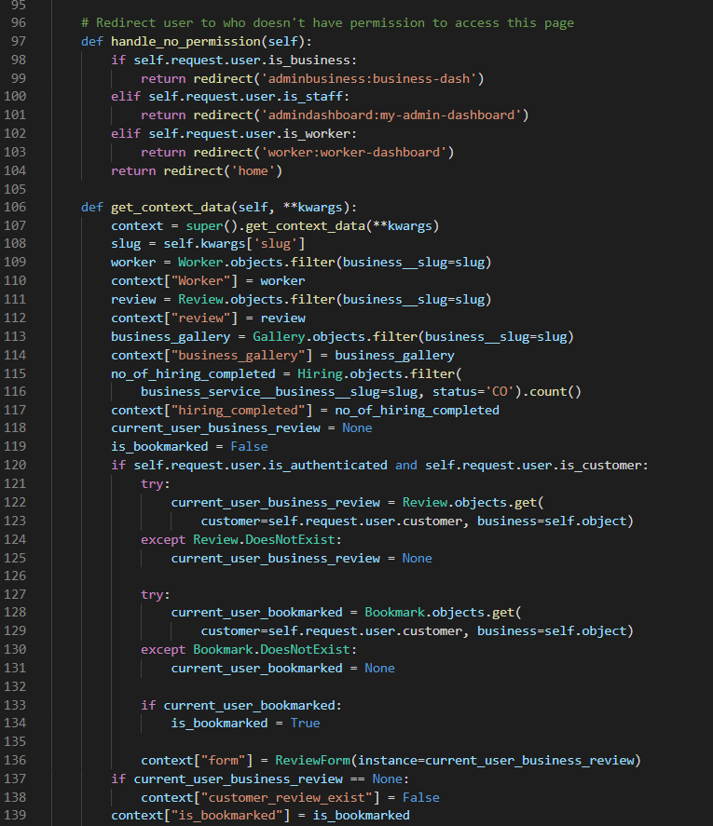

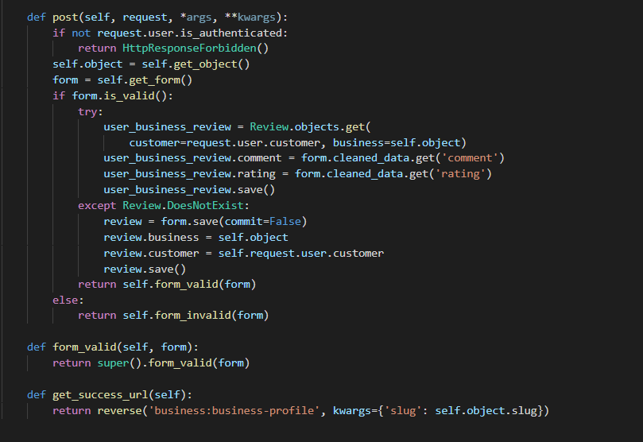

Figure: Business Views Code

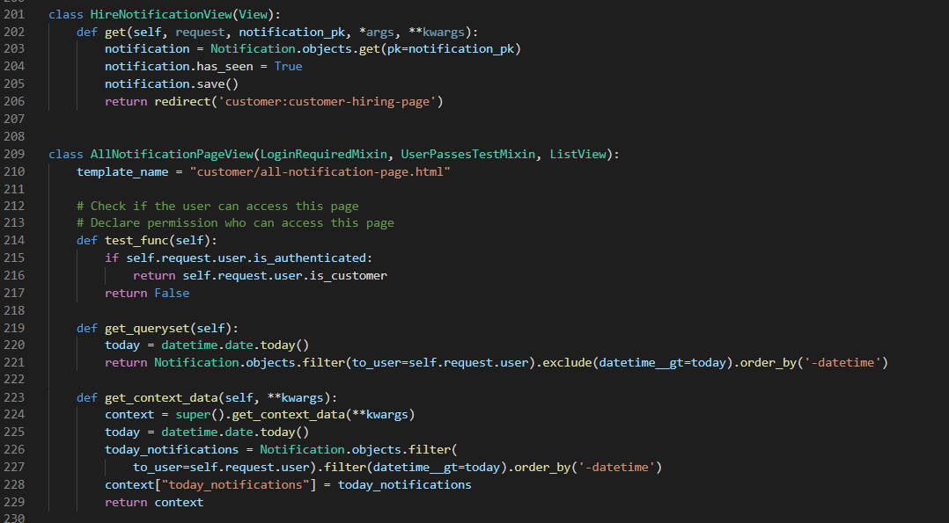

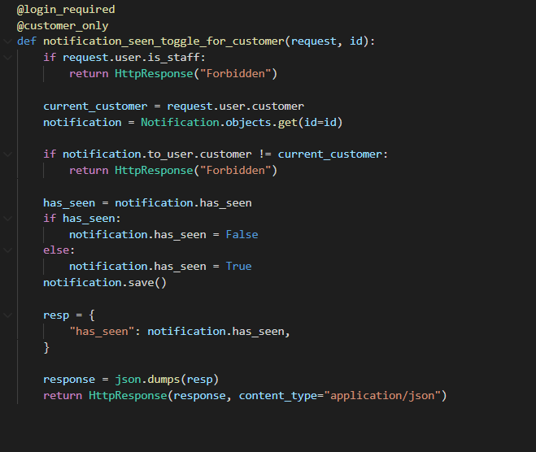

Figure: Customer views for Hiring and Notification

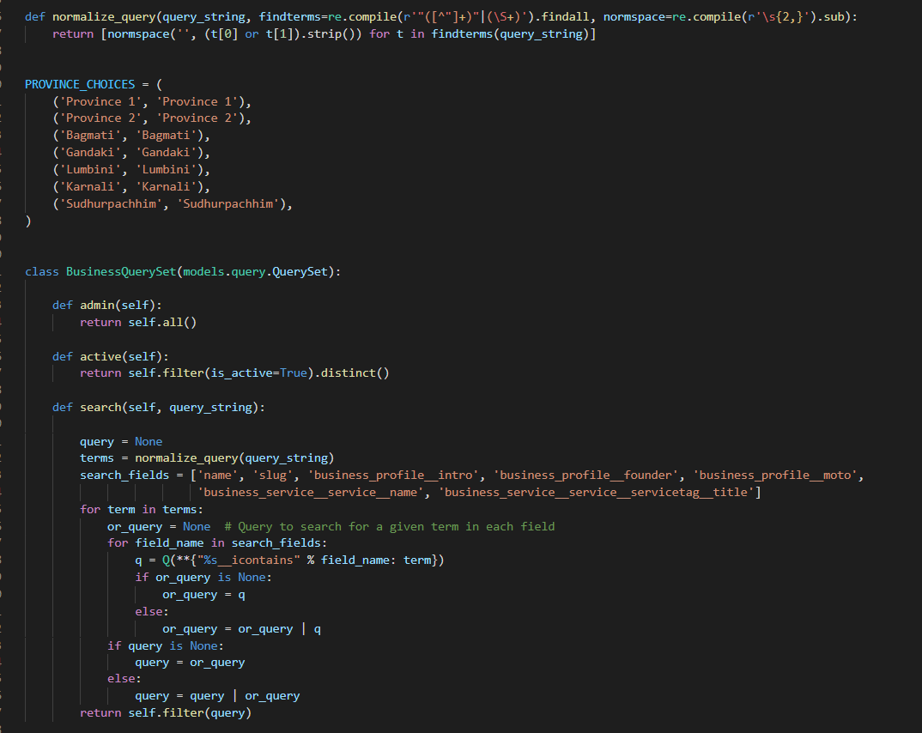

Figure: Business model code

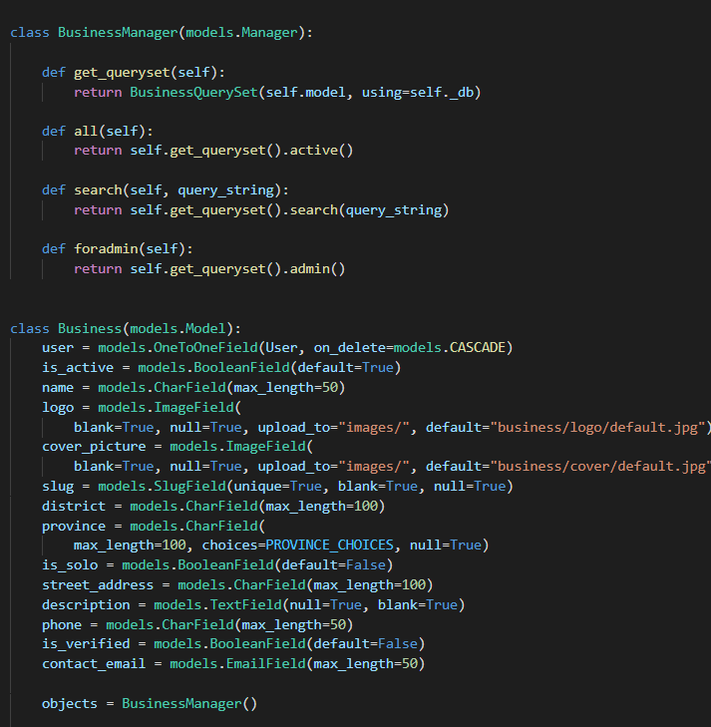

Figure: Business model code

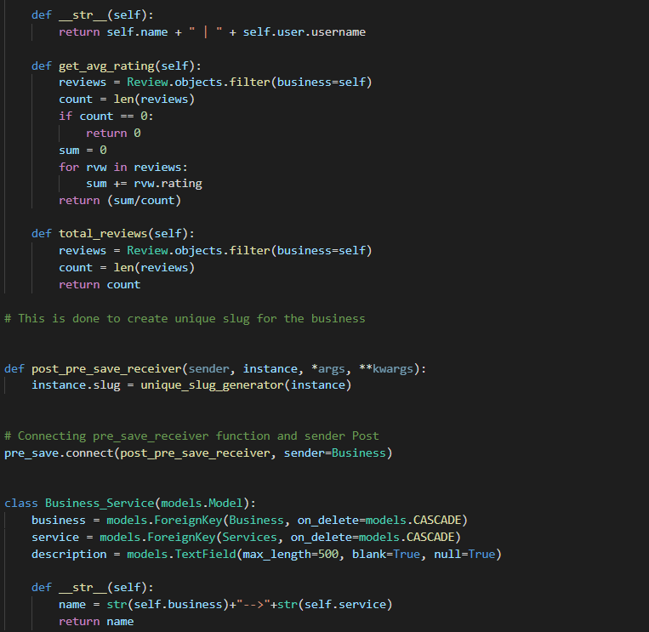

Figure: Business model code

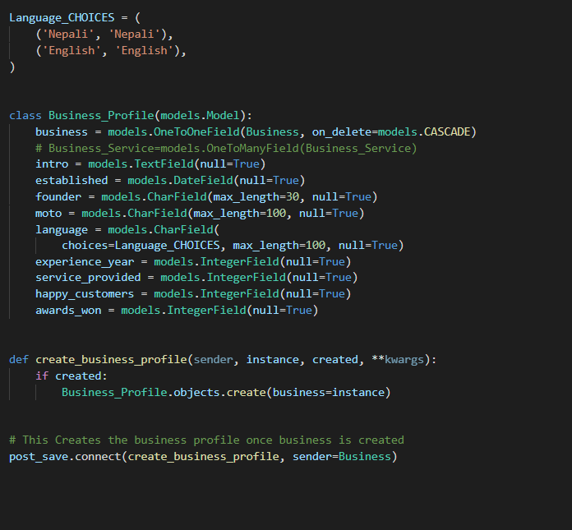

Figure: Business model code

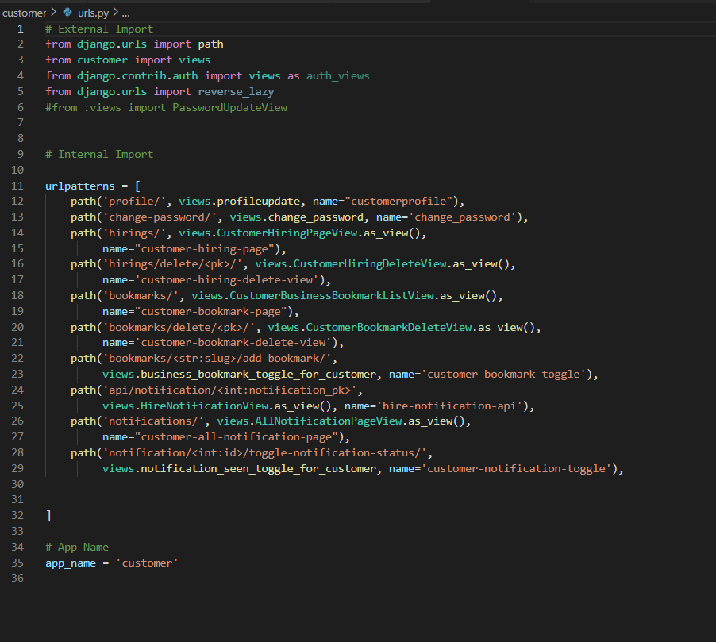

Figure: Customer URLS

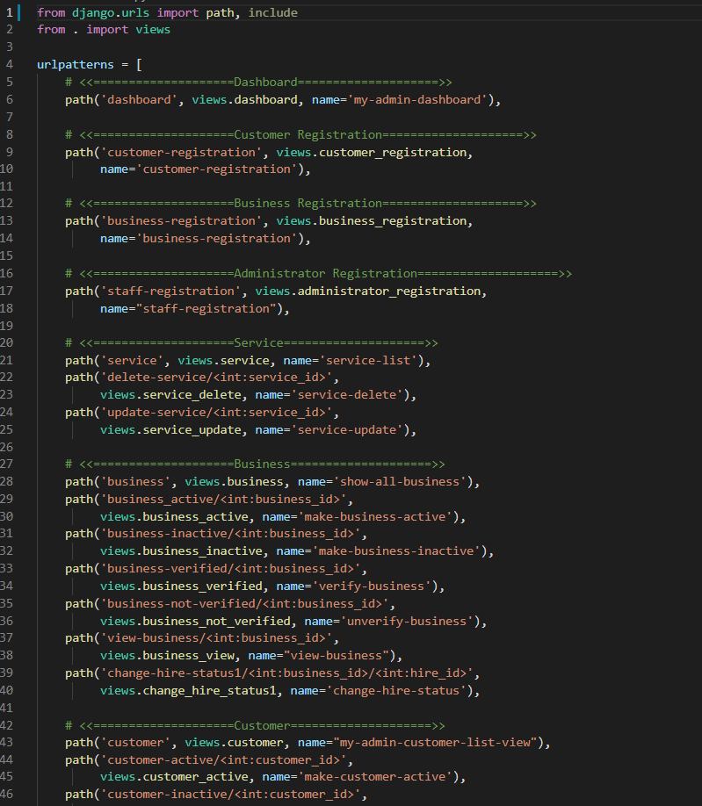

Figure: admindashboard url

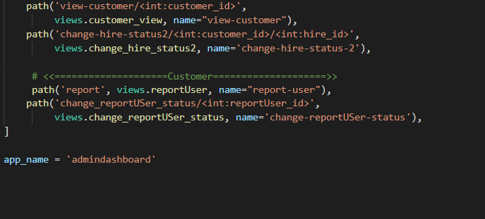

Figure: admindashboard url

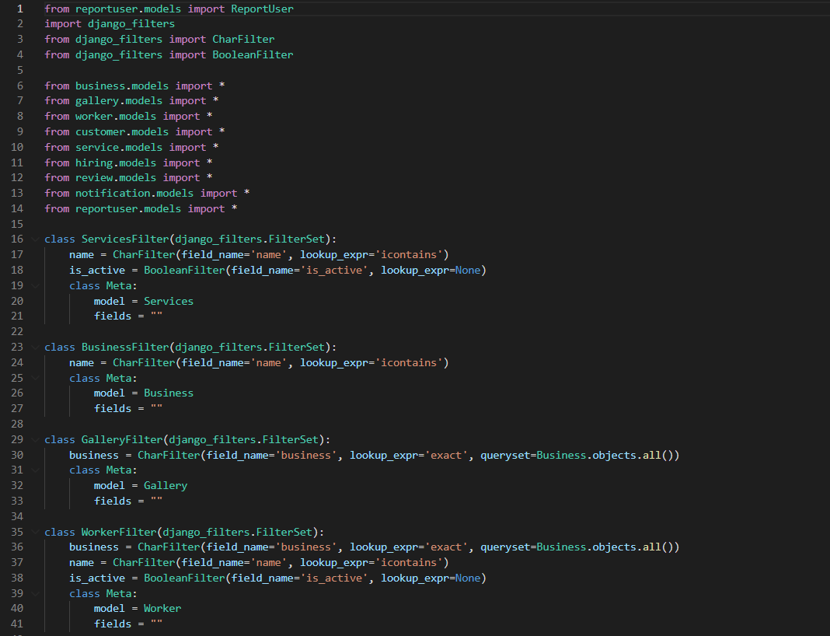

Figure: filters used in admindashboard

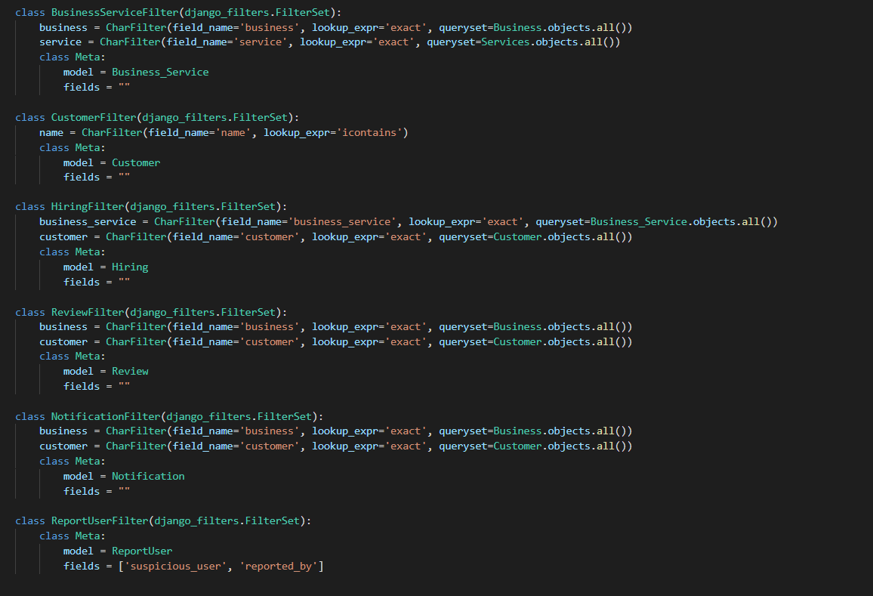

Figure: filters used in admindashboard

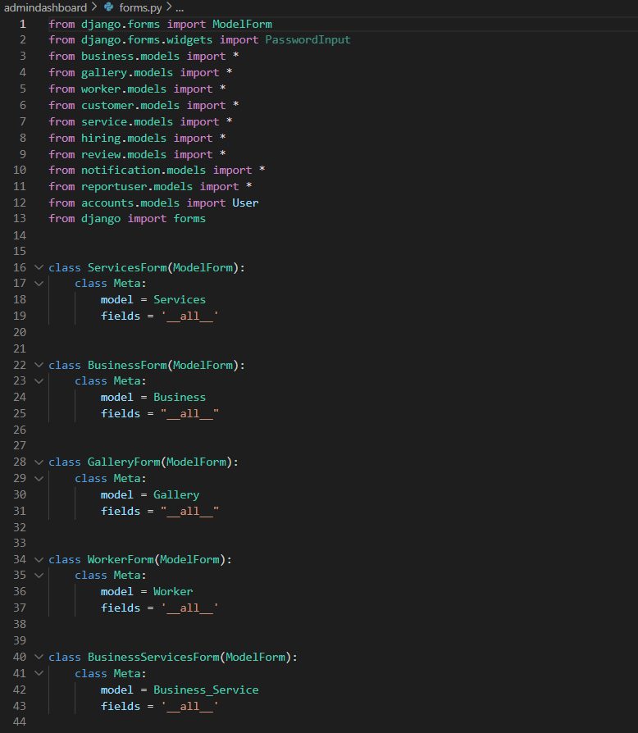

Figure: Forms used in admindashboards

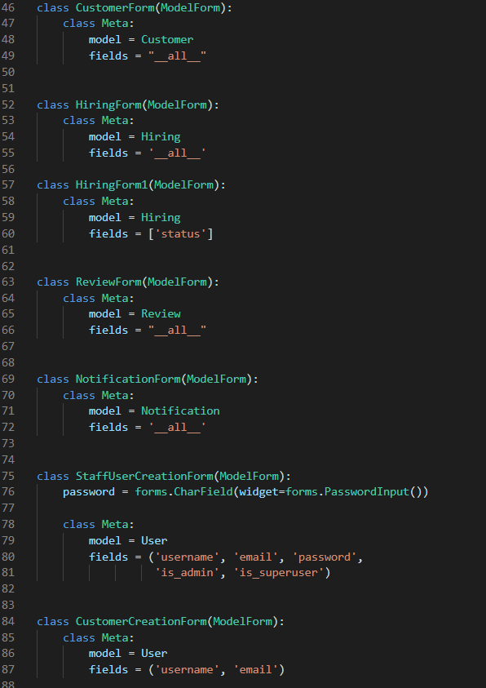

Figure: Forms used in admindashboards

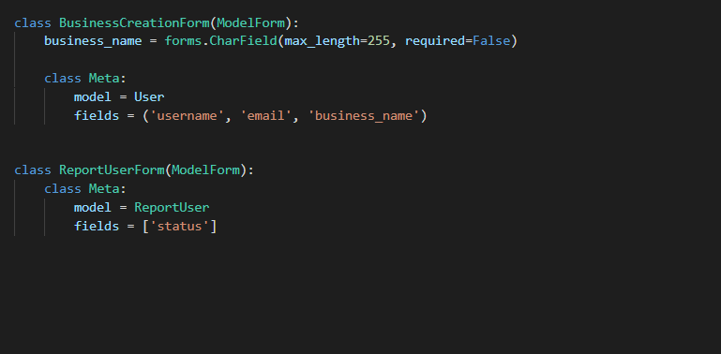

Figure: Forms used in admindashboards

References:

*UML Sequence Diagram Tutorial*. Lucidchart. (2021). Retrieved 23 September 2021, from <https://www.lucidchart.com/pages/uml-sequence-diagram>.